ECE 496Y Project Proposal (Draft B) Meeting Form |  | *Session Code (e.g. GT4):
Project No: 2011317 | Supervisor(s): M.Stickel | * Meeting Date & Time:
Project Title: Vehicle blind spot assist |  | ECC Staff:
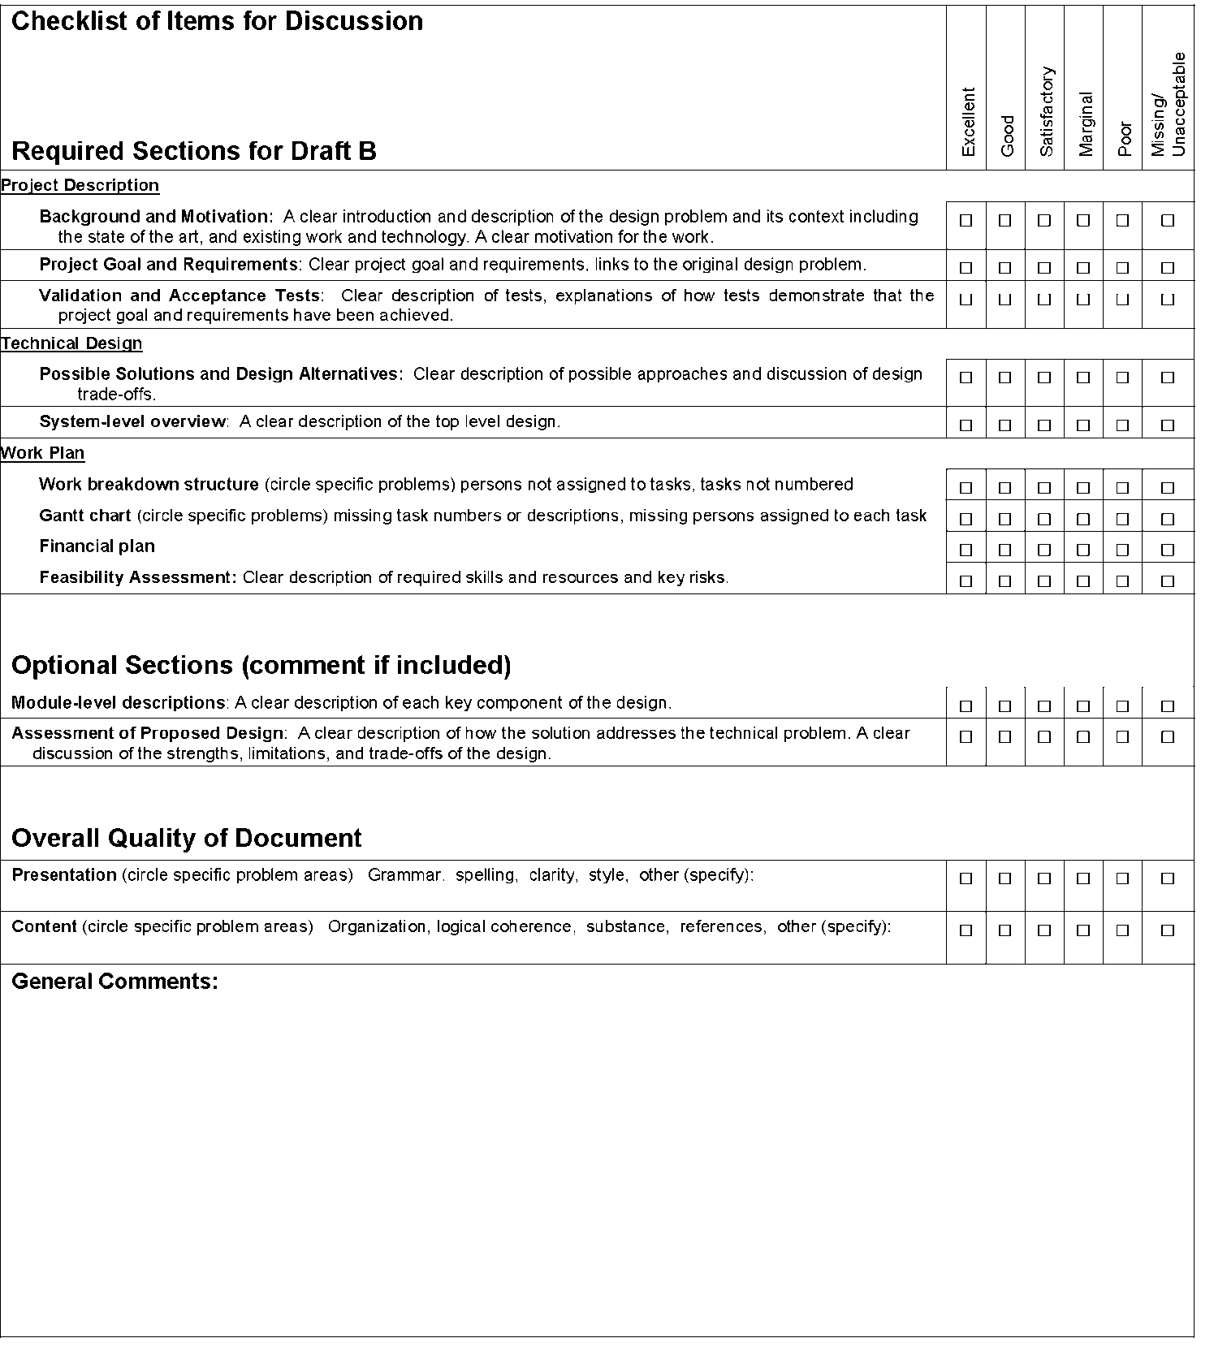

Design Proposal (Draft B)
Tanzim Mokammel 996155208
Valikhan Kuparov 997782877
Hani Hadidi 995921748
ECE496
2011-2012

Table of Contents

Section | Title | Page
1 | Background and Motivation | 3
2 | Project Goal | 3
3 | Project Requirements | 3
4 | Feasibility Assessment | 4
5 | Possible Solutions and Design Alternatives | 5
6 | Assessment of Proposed Design | 6
7 | Validation and Acceptance Tests | 7
8 | Work Plan | 8

1. Background and Motivation

Vehicle accidents are a big issue in Canada. They cause physical injuries, mental trauma, financial loss, and in the most extreme cases: death. According to Statistics Canada, in 2009, there were 123,192 total recorded collisions in Canada. 2,011 of these were fatal [1]. In 1990, total number of collisions was 178,515; 3,445 of which were fatal [1]. As seen, the numbers have decreased dramatically. This decrease can be largely credited to advancements in vehicle safety technology, among other factors. Though there is a decrease, as the numbers indicate, accidents are still a major issue.

It has been found that 95% of accidents are caused by bad driving behavior [2]. One common driver behavior is to not check the vehicle’s blind spot while changing lanes, which leads to accidents during lane changes. To account for this issue, car manufacturers such as BMW, Volvo, and Ford are introducing vehicle blind spot assist technologies in their new vehicle models. However, not every driver is able or wants to attain these vehicle models. Therefore, there is a need for a universal and affordable device that can aid users in becoming aware of obstacles in their blind spot. Advances to the currently available technology also need to be made to further prevent accidents in general.

2. Project goal

The goal of the project is to aid in accident prevention through a device that will aid users identify and anticipate obstacles in their vehicle’s blind spot. In addition, the device will be able attain vehicle control to automate lane changing. In order to achieve this, the group will build a prototype to be tested on scaled down vehicles (i.e.: RC Cars) and simulated road conditions.

3. Project Requirements
The device shall adhere to the following functions, objectives and constraints:
Functional requirements
- The unit shall have input sensors to obtain information about obstacles on adjacent lanes
- The unit shall have a computational element to process data from sensors and provide feedback
- The unit shall have an output module warning the user of unsafe lane changes
- The unit shall work independent of vehicle speeds
- Margin of error shall be less than 10%

Constraints
- The unit must cost less than $300
- The unit must weigh less than 1kg
- The unit must not violate any regulations set by the ministry of transportation
- The unit must not be a distraction to the driver
- The unit must not be a direct cause of an accident
- The unit must not impede the user’s view of the road
- The unit must be reliable

Objectives
- The unit’s input sensor shall work correctly independent of light and weather conditions
- The unit shall be affordable
- The unit shall allow automated lane changes in either direction
- The blind spot checker component of the unit shall be a standalone device and work regardless of vehicle make or model

4. Feasibility Assessment

Skills and Resources

The following skills will be needed:
- Knowledge of C++ programming
- Knowledge of microcontrollers (software/hardware)
- Knowledge of basic control theory(feedback mechanism)
- Knowledge of sensors and their operation
The team knows how to code in C++ from previous programming courses. Knowledge of micro-controller hardware will be gained by looking at manuals, and specification sheets. Software knowledge can be gained by looking through open source code for other projects on the web. The team already has basic knowledge of control theory. More advanced knowledge will be gained from remaining control courses. Knowledge of sensors has been obtained through research on the web, and looking at device specifications.

The following resources will be needed:
- Arduino Uno microcontroller kit
- SRF05 Ultrasound Sensors
- IR Sensors (for close approximation)
- One RC car to be used as vehicle in concern (VIC)
- Multiple toy cars to be used as blind spot obstacles (BSO)
- Test Track to be used for road simulation
The mentioned resources can be easily obtained once the development of the project is initiated.

Risk Assessment

We have identified the following risks:
- The SRF05 sensor will not always behave as expected, and there may be “dead zones”
  - Our solution to this risk is to add in a back-up sensor, which would fill in the dead zones of the SRF05. In addition, we need to create our controller in such a way that the two sets of sensors are able to interact without interfering with each other
  - We don’t have exact figures on the SRF05’s angle of operation. Therefore we will have to manually test these ourselves. Doing so will introduce delay, and uncertainty.
- Although the blind spot detection and anticipation component of the device aims to prevent accidents, user judgment is always necessary. Thus a risk would be that the device will be blamed for accidents. In such cases, it would be very hard to identify the device or the user as the culprit.
  - Our solution to this issue is to include a disclaimer informing users that the device cannot be held accountable for accidents. It is to be used simply for assistance, and does not replace user judgment.
- Within dense traffic, it will be very problematic if the user enables the automated lane change system. The device will not have any space to merge, and therefore cause disturbances in the driving.
  - Our solution to this issue is to ensure the user is unable to initiate the automated lane change system within heavy traffic. The device would also need to be aware of vehicles behind, and in front of the user vehicle in order to ensure there are no disturbances during the speed adjustments. This introduces the need for more sensors, and more complex algorithms
5. Possible Solutions and Design Alternatives
Alternatives were considered in the following aspects of the design:
- Controller/Compute Unit
- Input (Sensors)
- Output
- Automation

The following table outlines the alternatives considered, and compares them by their advantages and disadvantages:

Component | Possible solution | Type  fdg | Advantages | Disadvantages
Micro-Controller | Arduino |  | Programmed using C/C++; cheap | Expensive; relatively bigger in size
 | Picaxe |  | Comes with free software that allows flow charts; no programming required; easy to work with | Limited functionality
Input -  Obstacle Detection | Radar |  | Extremely large range; good accuracy | does not meet size constraints; expensive
 | Sonar |  | Good range and accuracy,  cheap | Complex programming required
 | Laser |  | Easy to implement; advanced technology allows data retrieval through USB | Requires a motor to rotate the sensors (low accuracy due to delay); expensive.
 | Camera -  image detection |  | Accurate; a duplicate can be produced to the driver | Complex image processing algorithms required;  expensive
Output - Feedback | Visual | Graphical | Very informative | Distracting; expensive; must be accurate and reliable to be useful
 |  | Numerical | Quantitative; fairly accurate; informative; | Distracting
 |  | Simple -  blinking light | Cheap; Easy to work with, simple | Not informative relative to other options
 | Auditory | Simple beeping sound | Easy to implement; cheap; simple | Not informative relative to other alternatives; irritating
 | Physical | Vibration of the  steering wheel | Very effective | Distracting; will not work universally
Automation | Automated Lane Merging System |  | Allows the user to easily and safely change lanes | Users may not want the car to change lanes automatically; the automated lane change system may cause the undesirable vehicle speeds dictated by cars in the adjacent lane; the automated system may not be able to change lanes fast enough for certain cases such as exiting the freeway
 | Counter Steer |  | Prevents side collisions | Takes away the user’s judgment factor; may cause a more serious frontal collision

Table 1: Possible solutions and Design Alternatives
6. Assessment of Proposed design
For our microcontroller, we decided to use the Arduino Uno. The advantages of the Arduino Uno are:
- I/O are easily accessible through sockets
- Wide variety of libraries and helpful online community
- Easily programmable using C/C++

The trade off for using the Arduino is that it is bigger in size compared to our alternative. This is an issue in terms of scaling, as it appears relatively large compared to our user vehicle prototype. In addition, powering the Arduino Uno as a mobile device may also be problematic as it requires further resources.

For our sensors, we have decided to use the SRF05 ultrasonic sensor. The advantages of the SRF05 are:
- Fast sampling rate (50ms or 20 times/sec).
- Large detection range (from 3 cm to 4 meters).

The tradeoff for the SRF05 sensor is that it is very expensive compared to alternatives such as IR sensors. The size of SRF05 poses further scaling issues However, its long range capabilities are essential to the obstacle anticipation feature.

For our output, a blinking LED light was chosen. The LED will blink as the car starts approaching the blind spot. As soon the car is within the blind spot range, the blinking light will turn into a solid light. The advantages of this solution are:
- Two modes of operation provide a simple, yet informative feedback
- Least costly among the alternatives

The tradeoff for using the LED is that it is very minimalistic, and may not appeal to some users.
For the automation component, it has been decided that a combination of counter-steering, and automated lane merging will be used. Both features are essential in ensure user safety during lane changes.
7. Validation and Acceptance Tests

The initial verification of the detection feature will be done through the following stages. Functionality of each prior state needs to be ensured before testing the following stages:

1. Stationary, where the both the user vehicle obstacle are at zero initial speed
- This case used to verify the most basic functionality of our system. Hence it will verify that the micro-controller is correctly receiving input from the sensors.
2. Moving user vehicles and stationary obstacles.
- The system should inform the user for as long as it is unsafe to change lanes due to the stationary obstacle being present in the blind spot.
3. Moving obstacle and stationary user vehicle.
- This test will verify the functionality of the anticipation feature. The system should identify obstacles that are approaching the blind spot of the user vehicle. An example of this feature could be used by the user safely exit a parallel parking spot.
4. Both obstacle and user vehicle are in motion
- This is the ultimate goal of the system and will integrate all the previous stages. The system should be able to identify vehicles within the user’s blind spot. In addition, the system should anticipate vehicles entering the user’s blind spot due the relative speed between the vehicles.

Tests will be conducted to ensure the system is able to inform users anytime during a lane change that it’s unsafe, regardless of whether an obstacle is already present, or approaching. For the case of obstacle anticipation, research will be done to identify the timing required to change lanes safely. The goal is to ensure the user vehicle can merge into the lane without causing the other cars to slow down, and still maintain a safe distance. In this situation, the worst case scenario will be considered where the driver swerves on the adjacent lane.

After all 4 stages of the detection and anticipation feature of obstacles have been verified, testing will be done on the automation feature. The automation feature consists of 2 parts:
- Counter steer of user vehicle if an unsafe lane change is being made
- Automated lane changing according to surrounding vehicles/obstacles

For the counter steer feature, the following aspects will be verified:
- counter-steer does not cause a frontal collision
- there is no overshoot during counter steer such that the vehicle moves onto the opposite lane

For the automated lane change feature, the following aspects will be verified:
- The user vehicle is able to merge in safely and smoothly without causing any disturbance to traffic
- The user vehicle remains within certain speed limits
- The user vehicle is placed in a sound location within the new lane

8. Work Plan

Work Breakdown Structure

Task Number | Task | Tanzim | Hani | Valik
 | 1. Obstacle Detection
 | - Research
1 | - Input (Sensor) | R |  | A
2 | - Output (LED) |  |  | R
3 | - Processing (Arduino) | A | R
4 | - Blind spot angles, sensor detection angles/ranges | R | A
 | - Implementation
5 | - Program the Arduino to allow input from the sensors | R | A
6 | - Program the Arduino to set up output display |  | A | R
7 | - Integrate the input and output components to display the sensor’s output on the display module; test the combined system | R | A | A
 | - Integration
8 | - Install the sensors and output module to an RC car | A | R | A
 | - Testing of the integrated system
9 | - Detection under the following cases:  - Stationary User Vehicle (UV), stationary Obstacle (O)  - Stationary O, moving UV  - Stationary UV, moving O  - Moving O, Moving UV | A | A | R
 | 2. Vehicle Anticipation
10 | - Design an algorithm to use relative velocity calculations in order to anticipate O in UV’s BS
11 | - Detect approaching vehicles and calculate their relative speed | R |  | A
12 | - Define safe distance and time constants to make lane changes |  | R
13 | - According to the 2 previous steps, display a distinct output to warn users of O’s in the UC’s blind spot | A |  | R
 | - Testing of the integrated system
14 | - Test O anticipation under the 4 mentioned cases | A | A | R
15 | - Test detection, and anticipation together; confirm the distinction of the 2 outputs | A | A | R
 | 3. Automation
16 | - Achieve full control of the RC vehicle through the Arduino; Test drive the RC vehicle w/ the Arduino | A | R
17 | - Implement IR sensors at the front and back of the UV; test their functionality | R | A | A
18 | - Test the functionality of all of the individual components after integration  - BS Detection  - BS Anticipation  - Front/Rear Obstacle Detection | A | A | R
19 | - Implement counter-steering with the Arduino using detection methods | A | R | A
20 | - Combine information gathered through the individual modules to design a system that will allow the UV to automatically merge b/w 2 vehicles in the adjacent lane | R | A | A
 | - Testing of the integrated system
22 | - Test w/ no moving obstacles (to ensure | A | A | R
23 | - Test w/ only one O in the adjacent lane | A | A | R
24 | - Test w/ both obstacles in the adjacent lane | R | A | A

Table 2: Work Breakdown Structure

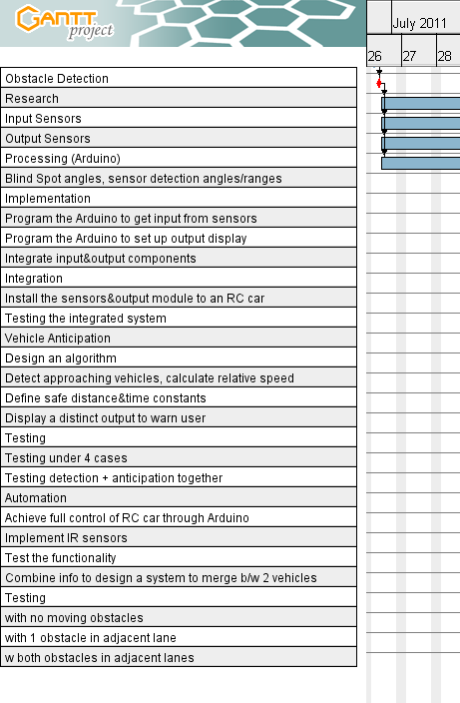
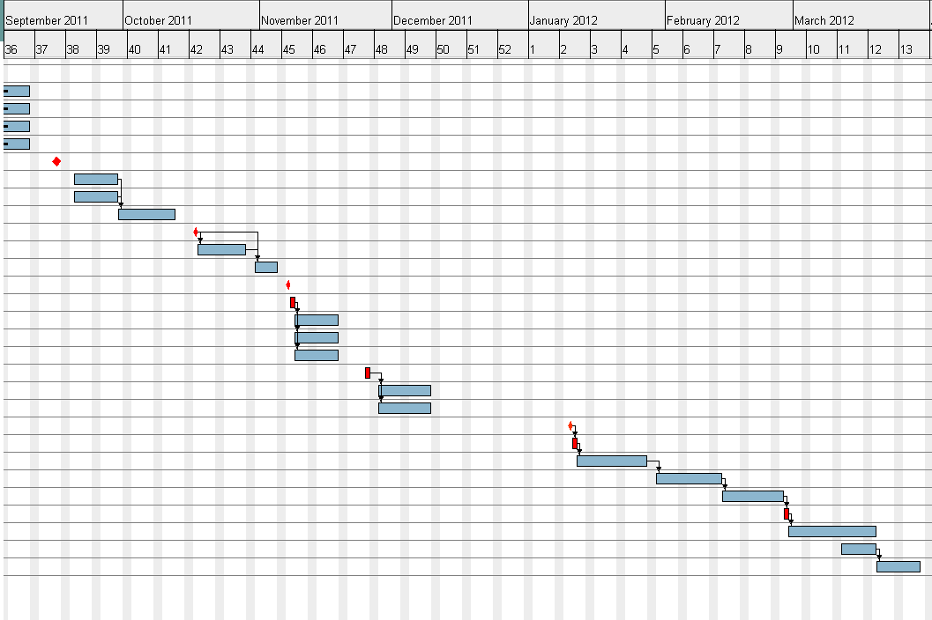

Figure 2: Distributed workload of team members

Figure 1: Gantt chart

Financial Plan
Item | Priority | Cost/per unit | Is it free? | Quantity  (# of hours) | Total Cost
Arduino Uno Microcontroller Kit  a. microcontroller  b. motor  c. manual | 1 | $82 | N | 1 | 82
SRF05 Ultrasound Sensors | 2 | $45 | N | 2 | $90
IR Sharp GP2Y0D805Z0F Digital Distance Sensor | 2 | $7.6 | N | 2 | $15.2
LED Breakout Kit | 3 | $0.6 | N | 1 | $2
LCD alphanumeric display | 6 | $12 | n | 1 | $12
Software | 4 | $0 | y | 1 | $0
RC cars:  a. 1 user RC car  b. 2 obstacle cars | 5 | $35  $22.5 | n | 3 | $80
Total contribution for 3 students | NA | NA | NA | 3 | $-270
Total contribution from supervisor |  |  |  |  | $0
Net amount requested from Design Centre | NA | NA | NA | NA | $300

Items to be kept and paid for by the student
Computer | NA | $1000 | n (previously purchased) | 1 | $1000
RC cars:  a. 1 user RC car  b. 2 obstacle cars | 5 | $35  $22.5 | n | 3 | $80

Table 3: Budget table
Our design consists of several essential parts: microcontroller, input sensors, output sensors. Unavailability of any design elements mentioned above will cause a failure of the design. In case of lack of funds, our team could alternate parts to cheaper ones. However, this will lead to a lack of performance, as well as reduction of design reliability.

References

[1] Transport Canada, “Canadian Motor Vehicle Traffic Collision Statistics: 2009”, Internet:
http://www.tc.gc.ca/eng/roadsafety/resources-researchstats-menu-847.htm, June 01, 2011, [Sep. 11, 2011]
[2] Unknown, “What Causes Car Accidents? “, Internet: http://www.smartmotorist.com/traffic-and-safety-guideline/what-causes-car-accidents.html, Unknown, [Sept 05, 2011]

